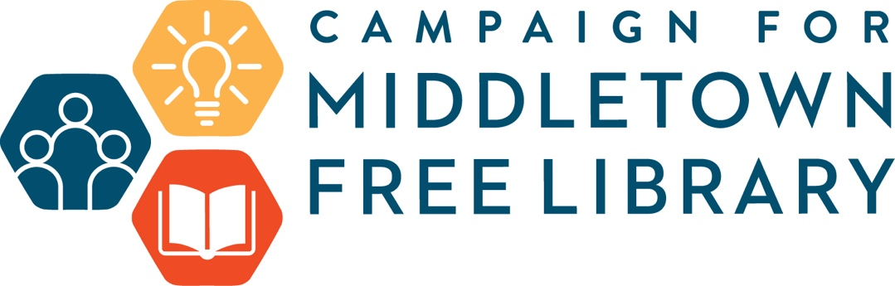

Ways to Give

Outright Gifts
Because campaign objectives are for the Annual Fund and the Roosevelt Project furnishings and outfitting, moving and other capital needs, outright gifts payable over the campaign period will be the focus for the Campaign for Middletown Free Library. We encourage you to make a pledge for your commitment, and make payments over up to three years.
- Cash
A gift of cash is available immediately for the organization’s use and in most cases is 100% deductible for donors who itemize deductions. Your check should be made payable to Middletown Free Library.
- Qualified Charitable Distribution (QCD)
A QCD is a direct transfer of funds from an IRA custodian, payable to a qualified charity, as described in the QCD provision in the Internal Revenue Code. Amounts distributed as a QCD can be counted toward satisfying your RMD for the year, up to $100,000, and can also be excluded from your taxable income.
- Gifts of Securities
Donors very often use appreciated securities – including publicly traded and privately held stock and mutual funds – to make capital campaign gifts. The attraction of this method of giving is that the donor is entitled to take a charitable deduction for the full current value of appreciated securities held longer than one year and is able to avoid paying the capital gains tax that would be due if the donor sold the securities. It is the policy of the Middletown Free Library to sell the securities immediately.
- Gifts of Real Estate
Real estate, such as a piece of land, a house or a farm, may be given outright, in which case Middletown Free Library will sell the property and use the proceeds for purposes of the capital campaign. A substantial charitable deduction may be claimed. Prior to acceptance, the Middletown Free Library must review gifts of real estate.
- Gifts-in-Kind
It is possible for a donor to give tangible property, such as books, furniture, artwork and jewelry to the Middletown Free Library. In most cases, the organization will choose to sell the property or item. It is very important to consult with a tax advisor before choosing to give an object to the organization. In-kind services may also be of value to the campaign.

Campaign for Middletown Free Library
Ways to Give

Planned Gifts
In order to increase their gifts, some individuals may make use of a planned gift in combination with an outright gift. The use and proceeds of a planned gift are deferred until a later date. To provide for the long-term health of the Library, the following may be considered:
- Bequest
A donor leaves a specific amount, a specific percentage of the full estate or the entire estate to the organization. A residuary bequest means that a donor gives the residue of the estate after other specific bequests are made to the organization. A contingent bequest means that the donor makes the gift dependent on certain events.
- Live-at-home gift
The donor transfers the ownership of his/her personal residence but retains the right to use the property for life.
- Gifts of Life Insurance
A donor may name the organization as one of the beneficiaries or the sole beneficiary of a life insurance policy. A donor may also transfer ownership of a policy to the organization. In the case of ownership transfer and/or sole beneficiary status, the policy’s face value is removed from the donor’s taxable estate. Also, future premiums paid on the policy by the donor can be treated as charitable gifts, and if the policy has a cash value, the donor can take an immediate tax deduction.
- Charitable Remainder Trust
The donor may give a specific amount that is placed in a trust managed by a financial institution. The donor gives up control of the funds but retains a life income interest in the funds. When the donor and other beneficiaries die, the remainder of the funds is given to the organization. This trust may take effect while a donor is still living or may be treated by the donor’s will
- Charitable Lead Trust
The donor gives the organization a specified amount that is placed in a trust for a specific period. During that time, the organization receives the income, and when the trust ends, the principal reverts to the donor. Usually, the donor is not taxed on the income that goes to the organization during the life of the trust.

Matching Gifts
Corporate matching gifts are a great way for donors to significantly increase the impact of their gifts. By taking advantage of a company’s matching gift benefit, you may be able to double or even triple the amount of a contribution. To find out if your company has a matching gift program, ask your employer.

