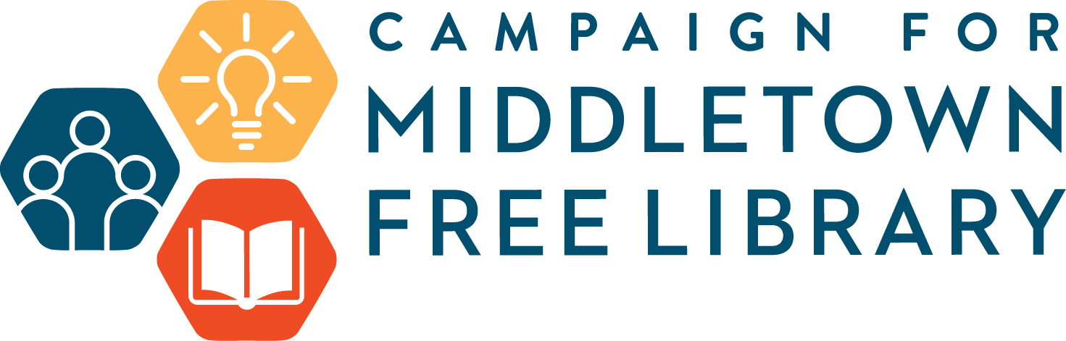
Middletown Free Library – Moving into the Future
Frequently Asked Questions

Why is the Library moving?
Middletown Township has purchased the former Roosevelt School at 464 S. Old Middletown Road, off 352, and has offered its use to the Library. The Library will occupy 12,000 sq.ft. of dedicated space and share 7,000 sq.ft. with Middletown Township including the entrance/circulation desk atrium and a Community Collaboration space. With the wide variety of programming offered by the MFL, 100 programs a month, the MFL has outgrown the available space. Popular programs reach capacity and have long waiting lists. During our busiest periods, parking is all but impossible. Since we do not own the parking area at our current location, or much of the land around the building we cannot add on to either the parking area or the building.
When are you moving?
The anticipated move date is Summer of 2021. Renovations at Roosevelt School have begun, and construction of the new Library space is scheduled to begin in Spring of 2020..
Why Roosevelt School?
Middletown Township is committed to the preservation of land and historic buildings. Restoring and repurposing this historic community asset, which dates back to 1921 is an excellent example.
What else does the site at Roosevelt School offer for the Library?
Parking at the Roosevelt site will accommodate 105 vehicles, a 50% increase from the current site. This site will also provide roughly triple the space the Library currently uses, providing more options for programming. We are also looking forward to:
More space for concurrent activities, one meeting room to five.
More spacious and accessible book stacks,
New space for quiet and collaborative activities
New Makerspace and Recording Studio
Fully ADA accessible facilities
6.2 acres includes building, parking and green space
Additional 12,000 sq. ft. of community activity space, including an auditorium

Who are the other “Community Partners” that will be sharing the space at Roosevelt School?
Currently the Middletown Historical Society is occupying part of the original building. After school activities such as Girl Scouts, Boy Scouts and Cheerleading also enjoy the use of the original building right now. The Township also hosts other community activities such as the Easter Egg Hunt, and Middletown Day at the site.
How much is this project going to cost? Who is going to pay for it?
The cost of the total project is anticipated to be $6.1 million dollars. Through the hard work and dedication of Library and Township leadership, a Pennsylvania State Keystone grant of $750,000 has been awarded to the Township expressly for this purpose. The Library has committed an additional $700,000 along with a commitment from the Township for $4,650,000.
What new services will the Library be offering because of the move?
New services will include a dedicated AV Recording Studio and a dedicated “Maker Space”. The many programs already offered will enjoy a lot more “breathing space”, as will our patrons. For example, our Children’s Area will increase markedly. New programs will always be explored and offered. The Library is proud to offer our programs for free, so they are accessible for everyone.
How can I help?
There are many ways in which you can help the Library.
ADVOCATE – This is your library! It provides vibrant areas of community outreach that transcend reading and reach out to all ages. Tell your friends and neighbors what your library means to you, and how important this project is!
VOLUNTEER - We are always in need of volunteers, daily, and also, physically, with the move. Your help is also needed in fund-raising.
CONTRIBUTE FINANCIALLY – Our Campaign for Middletown Library will cover the costs of outfitting and equipping the new Library and cover three years of the Annual Fund. It will run over 3 years. Please consider giving generously. We are asking for your consideration of a generous pledge so that the Library can continue with its award-winning services and programs.

Any additional questions can be directed to Mary Glendening, Library Director, midirector@delcolibraries.org or Bob Fyfe, President of the Board of Trustees, fyfe1@comcast.net

