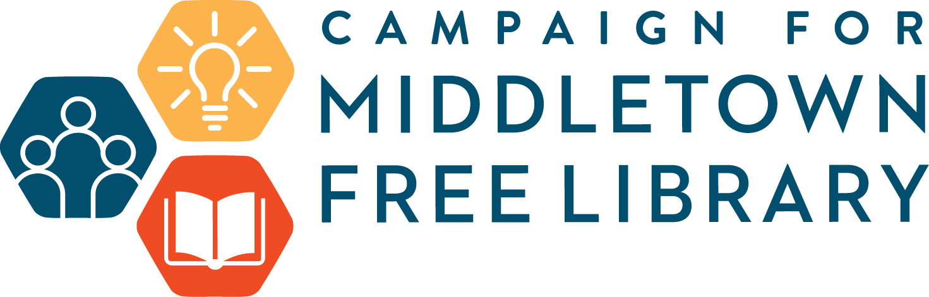

Middletown Free Library
Facility Improvement Case for Support

The Mission of the Middletown Free Library

To help the people of our community achieve their full potential through the transformative power of information, imagination and ideas.

Our Vision

We embrace the rich history and vibrant future of our community, Middletown Township. We are the welcoming heart of our community where people gather to explore, create, learn and connect. We envision a community that creates opportunities to unleash creativity, expands horizons and explores perspectives by: supporting early learning, lifelong learning and cultivating a joy of reading; responding to the needs of our diverse community; respecting intellectual freedom and confidentiality; providing technology and tools for creation; offering a safe space for exploratory conversation and the exchange of ideas. We seek to be the best public library by providing an atmosphere that is welcoming and respectful, creating a great place to work and visit for all who walk through our doors.

The efforts of this campaign will require patrons and community members to show their support financially at the highest level, as they have in the past, to transform the Library into a center for the community to connect, learn and prosper.

Our History

Founded in 1956, through the initial efforts of Mrs. Philip Sanders, the MFL started as a small book bus carrying 1500 volumes for circulation to a grateful community. Several thousand more were stored off-site, and many more donations were piling up. The bus ran Saturdays through the school year and weekdays during the summer.

Thanks to the efforts of many volunteers, it was a huge success. So much so that the library realized it needed a larger, stationary home. In November of 1959 the Weathers’ house on Pennell Road was purchased, thanks to the generosity of the community, then renovated and dedicated in May of 1960. Marjorie Spencer became the second Library Director.

By 1962, further expansion was necessary to accommodate the 19,000-volume circulation. The community again showed its support to fund a 1,500 square foot wing, ready for occupancy in June of 1963. As circulation tripled, in 1971 a 5,000 square foot two-story wing was planned, and the community’s generosity enabled the newest addition to be opened to patrons in 1973.
Further growth saw the formation of the Friends of Middletown Library to support its efforts to meet the needs of the community. Government grants provided funds to upgrade collections and furniture, and in 1981 the construction of the Community Room was funded by a grant from the Smith Foundation.

The Library has grown and changed with the times. Moving into the digital age in the 80’s and 90’s, we have a growing digital circulation and access to the county-wide library system, Delaware County Library System.

In 2014, our current Director, Mary Glendening, opened the doors to CreateSpace@MFL, as a published author in that area. CreateSpace@MFL is our version of Makerspace which is a collaborative workspace inside the library for making, learning, exploring and sharing that uses high tech to no tech tools. In addition to community access to the internet via four computers, the Library has also expanded its resources to include such cutting-edge technology as 3D printing.

The Middletown Free Library acts as a great community center, offering many programs for patrons of all ages and strives to provide the highest level of service and resources to all its patrons.

The Project

The MFL is a very popular place in our community. On average, over 250 people visit the library every day. There are approximately 100 programs offered per month. The current library facility is not adequate to meet the 21st century demands for programming, creation, work and collaborative space. The goals for relocation to the Roosevelt School include:

Current Challenges & Needs:

- Safety & Accessibility— The new library will be a welcoming space to visit for all users and especially for our users with disabilities. The new library will be fully ADA compliant through features such as wider aisles and lowered heights of bookstacks for all access browsing and accessible restrooms on both floors. A modern, centrally located elevator to allow safe and efficient access to the second floor. The library will feature an accessible service desk and a variety of seating options making for a comfortable and inviting environment for all. The parking lot will be expansive and allow for larger and more programs.

- Increased Program and Meeting Space—The new library will have a variety of meeting spaces with much greater flexibility. There will be three small rooms for quiet study, tutoring or small meetings, a dedicated CreateSpace@MFL for creative work, a recording booth for audio and video production and a large meeting space ideal for movies, lectures and larger gatherings. The library will have greater quiet space and room for patrons to move about. The demands of our CreateSpace@MFL and technology programming will not be constrained by inadequate electrical and technical technology.

- An environmentally conscious building—The current building is comprised of the original library, which was built as a home in 1819, and 2 additions made in 1962 and 1973. The new library will be efficient at heating and cooling. The current library is dependent on heating oil and with three large oil tanks, this method of heating is expensive and not sustainable. Many of the large picture windows are single-paned glass and not well insulated. Energy efficiency will be achieved with better windows, and improved air flow.

- Quiet space to gather and work--The new library will provide quiet spaces for reading or working. We will no longer be required to constantly rearrange furniture to accommodate a busy programming schedule, users looking for a space to work or read will find the ideal space to accomplish what they came to the library to do.

- A comfortable space to gather and work— The new building will provide a comfortable environment to relax with a good book, chat with friends, meet for book club or do homework.

The Solution

Middletown Township Support

Middletown Township has provided approximately 60% of the Library revenue since the1980s. In 2015, the Township acquired the historic Roosevelt School facility (36,000 sq.ft.) and surrounding 6 acres for community preservation and community use. As the challenges of efficient space for Library growth increased, the idea of moving to the Roosevelt School took shape.

The Library will occupy 12,000 sq.ft. of dedicated space and share 7,000 sq.ft. with Middletown Township including the entrance/circulation desk atrium and a Community Collaboration space. There are an additional 12,000 sq.ft., primarily in the 1921 Roosevelt building that houses the Middletown Historical Society, space for community group activities and an auditorium. A Veterans Memorial is also planned by Middletown Township for the front yard.

The Library Board made the decision to accept the Township’s offer of a long-term lease for $1 per year. The Township and Library submitted a proposal for a Commonwealth Keystone Grant in 2018. We were awarded a $750,000 grant, the largest in the history of the state program, with Middletown Township commiting to match the amount. The grant will be utilized to help renovate the 1956 wing of Roosevelt School for Library and community use.

The building project will cost $6.1 million, with Middletown Township providing a total of $4.65 million and the Library will provide $700,000 to furnish the Library facility.

A Memorandum of Understanding will detail the partnership and include the Township purchasing the current 6,700 sq.ft. facility at the appraised market value. [The Library Board plans to hold the net proceeds in a Board-restricted fund to support ongoing operating budgets]
For donor purposes, the Campaign for Middletown Free Library will support the $700,000 project costs as well as three years of the Annual Fund.

Optimal Fiscal Case

Annual Fund (Three Years) $ 300,000
Friends of the Library
Program Sponsors
Grants
Individual Donations

Capital Expenses for Move to Roosevelt $ 700,000
Furnishings for Common Areas $140,000
Furnishings for Offices and Meeting Rooms $105,000
Welcome Desk and Entrance Area $105,000
Flexible Shelving and Stacks for Books $280,000
Window Coverings and Floor Covering $ 70,000

Optimal Goal Total $ 1,000,000

TimeLine

Contract Begins | Fall 2019
Construction Starts | January 2020
New Library Opens | Summer 2021

